Civil Rights and Me Lesson 2: Bullying

Objectives  Students will be able to...  - Define bullying behavior in person and online and provide examples  - Identify strategies for online safety  - Demonstrate an awareness of other people's perspectives and a respect for individual differences.  - Identify ways to develop empathy toward victims of bullying | Materials Needed  - Sticky notes (1 pad of post-its per group)  - Markers  - Pencils  - Poster Paper (4 large/class size sticky pad papers)  - Printing Paper  - Powerpoint

Time | Description and Talking Points | PPT Slides  Reminder: Read Slide Notes
1-2  minutes | Objectives: Read objectives on the slide or have students popcorn read them | 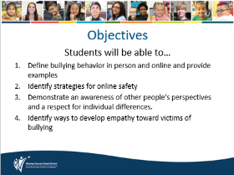
2-3 Minutes | Working Agreements: read agreements or have students popcorn read the agreements; discuss if necessary | 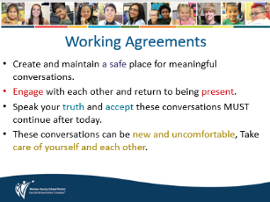
1-3 minutes | Warm-up: Maya Angelou Quote  - Have students read the quote.  - Have students think of an individual response to the quote  - Students discuss what the quote means to them. Share answers with groups. Share answers as a whole class if time permits. | 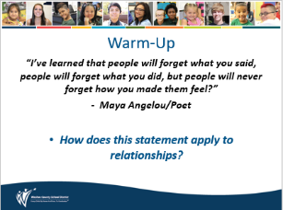
2-3  minutes | Discuss/Think-Turn-Tell:  - Provide students time to discuss what bullying means to them.  - Read the provided definition of bullying  - Discuss the difference between a mean moment, conflict and bullying | 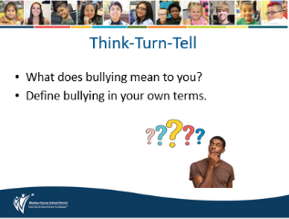
3-5 minutes | Key Vocabulary:  - Use notes from the slide to discuss key terms for the lesson (slide 6)  - Use notes from slides to discuss the components of bullying (slide 7)  - Use notes from slide to discuss the types of bullying (slide 8)  - Discuss the difference between a mean moment, conflict, and bullying (slide 9)  **See slide notes for Digital Learning Adaptations** | 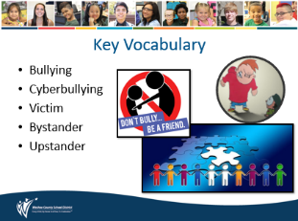
9-12  minutes | Activity (Gallery Walk): How does bullying impact everyone involved?  - Using 4 class size poster sticky notes, title each one as the following: Bully, Being Bullied, Upstander, Bystander  - Post 1 class size poster sticky note in each corner of the room  - Provide students individual sticky notes to write an answer about what it feels like to be a bully, what it feels like to be bullied, what it is/feels like to be an upstander, what it is/feels like to be a bystander  - As students write their answers on sticky notes, allow them to post them on the large class size poster sticky notes placed in the corners of the room- they should match their answer with the appropriate topic  - Allow students 3-5 minutes to walk around the room and see what their peers wrote  - Read some answers from each topic if time allows  **See slide notes for Digital Learning Adaptations** | 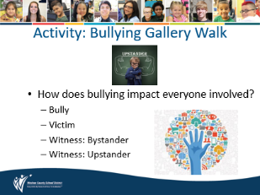
5 minutes | Video: Cyberbullying  - Play the video: What is Cyberbullying???  - Link not working?? Here is the URL to copy and paste in your address bar https://www.youtube.com/watch?v=6ctd75a7_Yw  - Students will discuss cyberbullying after the brain break  **See slide notes for Digital Learning Adaptations** | 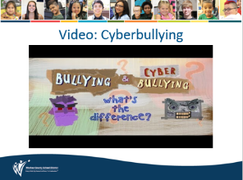
3-5 minutes | Brain Break: Choose slide 12 or 13.  Rock Paper Scissors Tournament: Use if class needs energized! Play rock paper scissors. One win and you find another opponent. If you lose, you follow the person you lost to and cheer for them. Last two people in the room play best of 3.  OR  Compliment Paper Toss: Use if class needs to collect themselves. Have students write down 2 compliments on a piece of paper. Crumple the paper up and toss it around the room. Have each student find a piece of paper and read the first compliment. If time allows, repeat for the second compliment.  **See slide notes for Digital Learning Adaptations** | 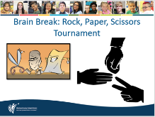  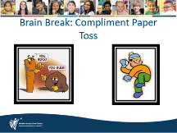
1-3  minutes | Review Working Agreements:  - allow students time to silently review working agreements | 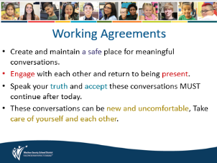
5-7 minutes | Activity: Think-Turn-Tell  - Use the questions on the slide to direct conversations. use the slide notes to help facilitate questions.  **See slide notes for Digital Learning Adaptations** | 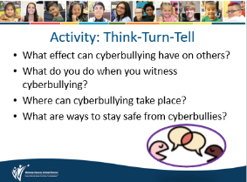
2-3 minutes | Ways to Stay Safe Online:  - Read slide to students or have students popcorn read the slide  - Review SafeVoice and tips for reporting (slide 17) | 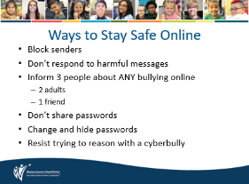
10-12  minutes | Activity: Student Art Poster  - With a partner, have students create a poster about cyberbullying.  - Have students complete this prompt… Cyberbullying is when_________  - Under their response, ask students to identify ways cyberbullying can hurt someone. (create a list or draw a picture)  - Ask students to decorate their posters  - Have students share their poster with their group  **See slide notes for Digital Learning Adaptations** | 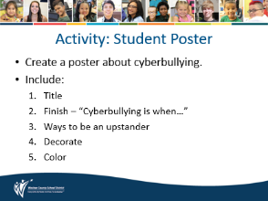
5-7  minutes | Activity: IF___THEN___ Plans:  - How can you be an ally if you witness someone being bullied online or at school?  - Share ways to be an ally with a person being bullied. (teacher directed or class discussion)  Allow students to create their own IF, THEN plan for each prompt.  - If I see someone bullied at school, THEN I will______________________  - If I see someone bullied online/virtually, THEN I will______________________  **See slide notes for Digital Learning Adaptations** | 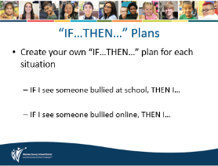
5-7  minutes | Wrap-Up: Whip Around  - What is one takeaway from today? How did you make a personal connection?  - Students can think about their answers. Then hold a small group discussion. Have one person be a spokesperson to share 1-2 of their groups’ responses with the class.  - Each group should have one speaker and one response prepared. Call on each group to share their answers.  **See slide notes for Digital Learning Adaptations** | 